set up Autolaunch Correctly

**by Marc Hoffmann  
Editing and color commentary by Steve Schlesinger**

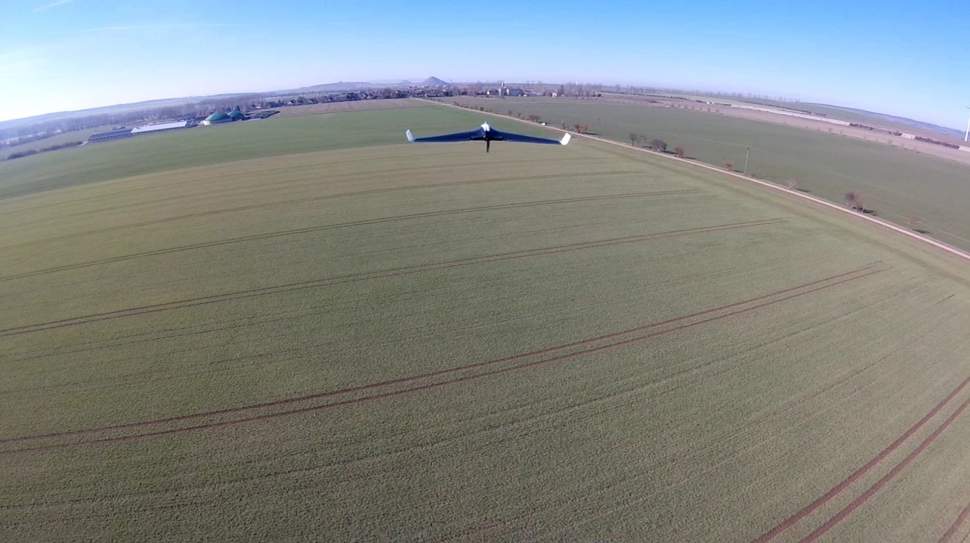

Table of Content

Introduction 2

Autolaunch Settings 2

Main Settings 3

How to Choose Each Setting 3

Optional Settings 5

How to Choose Each Setting 5

Determining throttle setting 6

Is your plane ready? 7

# Introduction

The INAV Autolaunch mode is a very useful feature for all kind of planes that need to be hand-launched. With this helpful feature it is much easier to throw-launch a plane and much safer than throwing a plane with a propeller spinning at 10k rpm, especially if you have a pusher plane. In general, the Autolaunch feature works out of box for most planes. Just enable the mode and you are good to go. But you’ll have to have a setup with a perfect thrust to weight ratio, and you will need to do a perfect throw in the right angle and with good speed and hopefully you’ll have a little bit of luck. If your planes are too important to you to trust them to pure luck, thankfully we’ve got your back. In this guide we will explain the launch mode in detail and help to show you how to find better settings for your plane and make Autolaunch as easy as throwing a paper plane - except of the fact, that your plane will keep flying!

# Autolaunch Settings

The first thing to know: The relevant Autolaunch settings are not (yet) accessible through the configurator GUI. You need to do the necessary changes in the CLI mode. There are an infinite number of possible combinations for these settings that all need to work together to make your plane launch well. But if you understand each option and how to decide the best values for your needs, it makes life much easier. In the following table you will find all the essential options and how to set them with some additional functions, to make Autolaunch better tailored to your specific needs.   
  
The thing that is crucial is that you have a plane that flies stable. We’ll be talking more about this in future articles. In the meantime, the rule of thumb is that you want a plane that can fly well in manual and in angle modes with no trims. You also want a plane that doesn’t freak out’ because the PIFF values are set too high. This means you’ll need to get your plane to a point where it’s ready for the Autolaunch.   
  
If you decide to use Autolaunch for your maiden (not recommended), make sure you select a good close preset in the "Preset" Tab that closely fits your plane and select low PIFF values. Especially for smaller wings these should be maxed at PIFF 8, 5, 50 for pitch and roll and even lower on yaw (can be 5,0,50). We don't really need an I gain on yaw.

## Main Settings

|  |  |
| --- | --- |
| CLI name and default value | Description |
| nav_fw_launch_max_angle = 45 | Max throwing angle that is allowed to be accepted as a valid launch throw |
| nav_fw_launch_thr = 1700 | Motor throttle value during launch procedure |
| nav_fw_launch_idle_thr = 1000 | Motor throttle value when armed and before launch |
| nav_fw_launch_motor_delay = 500 | Wait time after throw, before motor goes to launch throttle power |
| nav_fw_launch_spinup_time = 100 | Time for incrementally increase the throttle from idle to launch throttle to avoid motor stall |
| nav_fw_launch_climb_angle = 18 | Angle to climb at during launch sequence |
|  |  |

### How to Choose Each Setting

#### nav_fw_launch_max_angle

The launch angle depends on the way you launch your plane. If you have a standard fixed wing like a trainer (5 channel) or a Talon style, you probably launch it with one hand under the fuselage and throw it like a big paper plane. In this case the default angle of 45° is totally fine to avoid accidental launch detection when carrying the plane after arming it. For flying wings, you launch with a wing throw (not recommended because Autolaunch could flip it and crash into ground with full throttle) this is fine too. If you decide to do an over-head launch (by throwing it backwards over your head) you need to set this value much higher. It is fine to select 180 in this case.

#### nav_fw_launch_thr

The launch throttle is mostly depending on 2 factors: The thrust to weight ratio of your plane and the capabilities of your hardware (battery, esc and motor power capabilities). We recommend a value where your plane is close to over, when you hold it in our hand nose up and throttle up manually but would not climb if you would let it go (of course do not do that!). If the plane is very big and has a low thrust ratio, set this to 2000. Also check the current that is needed to obtain the selected throttle value on the bench. Your battery, ESC and motor need to tolerate this amount of throttle for about 10s without overheating, to avoid any damage. (See ‘Determining throttle setting’ for more information on this topic.)

#### nav_fw_launch_idle_thr

By default, the idle throttle is set to 1000 which means no throttle. This is totally fine on standard props. There are 3 scenarios where you can or even should select a higher value to keep the motor already spinning before you throw it.

Scenario 1: You have a very low thrust to weight ratio, or a very heavy plane and you needs an extra push when throwing to gain speed faster and avoid a stall or height loss. A Good value here would be 1200-1400 depending on your motor power. Be aware, that the motor will spin at relative high speed as soon as you raise the throttle after arming!!!

Scenario 2: You are using a folding propeller. It can be very stressful for your motor, props and even fuselage if a folding propeller is spinning instantly to 100% power if it is folded. So, you can use a low value like 1100 to make sure the prop is open and in balance before launch.

Scenario 3: If you really want to launch a wing b a wing throw, it makes sense to give it a high idle throttle value. This avoids a strong yaw spin when throwing the wing and makes your launch more stable. Half to two thirds of the launch throttle value is recommended in this case. An example, if your launch throttle is 1700 this should be set to 1350-1450.

We recommend to keep Motor Stop feature enabled to avoid motor spin on arm. It will spin at idle throttle as soon as you rise the throttle stick on the remote.

#### nav_fw_launch_motor_delay

This delay brings extra security, especially for pusher planes. By default, this is set to 500ms but especially for smaller planes, that quickly lose speed because of low weight, this time may be too long, and the plane will hit the ground before the motor has full power (which would suck). Therefore, you should lower this value. We recommend a value of 200ms. For pull-prop planes (nose propeller) you can even set this to zero. Do not set this to zero on pusher planes because the propeller could hit your hand with full speed (unless you wing toss, in which case this is fine).

#### nav_fw_launch_spinup_time

As soon as the launch is detected and after waiting for the motor delay time, the FC will power up the motor. By default, the throttle will rise smoothly from idle throttle to launch throttle in a timeframe of 100ms. This is important to avoid motor stall, especially for bigger props and folding props. For planes with 8-10-inch props we recommend even 200ms and more on larger propellers. You can test this on the bench to make sure the motor gets full power without stuttering (but be careful).

#### nav_fw_launch_climb_angle

After launch throttle, this is the most important value and it depends on a multitude of factors. Motor Power, weight of the plane, throw speed and possible lift. Big planes or motor glider with a very high lift ratio and low thrust, should keep a low climb angle like the default 18°. Also, small planes with a low thrust to weight ratio should keep a lower angle but not below 20° because they can quickly loose speed while motor goes to full power. Then the FC need to pitch harder up to gain back height. Also, a bit higher P-Gain in PIFF controller can help to get a quicker climb angle. We recommend 25-30° but make sure the plane can sustain speed at this climb angle without stalling. If you have a highspeed setup and a lot of power, select a very steep climb angle.

During the first second or two, while the plane is accelerating, this causes backwards G-forces that could make the FC “think” it is already climbing and can cause even a nose down in some conditions. Therefore, the thrust for launch should never be higher than the plane could hover on its propeller. Better slightly lower to get a quick and correct climb angle.

## Optional Settings

|  |  |
| --- | --- |
| CLI name and default value | Description |
| set nav_fw_launch_accel = 1863 | Needed G-Force when throwing to detect launch |
| set nav_fw_launch_detect_time = 40 | Time in ms the launch acceleration needs to be exceeded to accept the launch |
| set nav_fw_launch_min_time = 0 | Time to ignore any stick input after launch sequence has started |
| set nav_fw_launch_timeout = 5000 | Time for the launch sequence to run. After that the Plane will switch to the actual active flight mode. |

### How to Choose Each Setting

#### nav_fw_launch_accel

It is not necessary to change this value. By default, this means, the FC need to detect a force of 1.8G to accept the launch throw. For big and heavy planes, this can be lowered because they are harder to throw. But be careful, because launch detection will be more sensitive and accidently launch activation could happen.

#### nav_fw_launch_detect_time

This should not be changed for throw launches. It is a good value to get a reliable launch detection. For a catapult launch you can set this a bit higher, depending on the length of the catapult. But it is more useful to rise the motor delay time than the detect time.

#### nav_fw_launch_min_time

If you launch your plane while you have your remote in the other hand, it can be safe to set some delay here. Especially on some remotes with very sensitive sticks, this can avoid accidental Autolaunch aborts when the remote gets a shake during the throw. We recommend to not go above 2000 (two seconds) to still be able to gain control and abort a launch as soon as possible if needed. This means for a full two seconds you will not be able to control your plane.

#### nav_fw_launch_timeout

Sometimes the default 5000 (five seconds) can be a bit short to take the remote, put on your FPV goggles and take a seat in a camping chair, crack open a brewski, open some Dorritos. So it is always a good idea to rise this value up a bit. In theory this can be set up to 60s (value 60000) but then the plane will fly far away. But hey, this is a good time to wonder if you have your RTH set to first launch? You ask Marc to tell you a funny story about this topic. Set a value that is comfortable for you.

#### nav_fw_launch_max_altitude

By default, this value is disabled. But if you want the plane to always climb to a specific height it makes sense to put a useful value here (in cm). The plane will then abort the launch sequence as soon as the set height, or as soon as the timeout is reached. To make sure the height is reached, you need to set launch time high enough, especially at flat climb angles. But we recommend to not disable launch timeout. Otherwise this can cause a flyaway if the barometer or GPS height fails, because during launch, failsafe RTH is ignored due to a bug in INAV 2.0 and 2.1. (will likely be fixed in 2.2).

# Determining throttle setting

The first thing is that throttle settings influence thrust but there isn’t a one-to-one correlation between throttle setting and thrust. What this means is that the best throttle setting for your plane will be plane specific. We would love to tell you a value at this point that you could use for all your planes. You will need to perform this test for each plane.  
  
When you look on your receiver tab in the INAV configurator, you will notice that as you move the throttle up and down the values change. In a perfect world the very bottom of the throttle range is 1000. 1000 represents ”no throttle.” In reality it may be something like 980. If you haven’t calibrated your receiver in a while this may be the best time to do it. it’s common for the sticks to be of a bit, and it won’t affect performance of the plane. But for the rest of this example, we’ll talk as though your throttle was perfectly calibrated. This would mean that 1000 is off and 2000 would be full throttle. 1500 would be half throttle. Thus 1250 would be quarter throttle and 1750 would be ¾ throttle. If this doesn’t make sense, go back and read this again. You will need to guestimate a number and it should be fairly close to accurate for best performance.  
  
Hold your plane straight up with one hand and with the other you’ll need to work your throttle. You may want to do this outside. With the throttle off you will feel the full weight of the plane in your hand. As you fire up the throttle the plane will become lighter. When it feels like it’s just about ready to fly out of your hand, note where the throttle position is. If you're at half throttle the number would be 1500. If you have a woefully underpowered plane the value may be closer to 2000. Use this value for nav_fw_launch_thr.

# Is your plane ready?

One of the most important assumptions we make about Nav Autolaunch is that your plane is setup well. What you need to keep in mind is that for a short period of time your plane is flying by itself. So, let’s use some common sense. First of all, go somewhere that you’re able to launch the plane that is away from people and property. Sometimes things go wrong, and we just want to be sure that we keep your risk exposure low.  
  
The second thing is, if your plane is flying wonky, don’t play with this mode. You are going to want to focus your efforts on getting your plane flying well. A flight controller helps a good plane fly better, but it can only do so much for a plane that isn’t set up well. We’ll be covering this topic more in the future, but the gist is to make certain your plane can fly well in the manual mode without trims. Then use servo auto trim and autotune to make certain your plane is flying well in the stabilized modes. If the plane is pitching down in stabilized modes, you can add more ‘nose up’ with a positive pitch value in the configurator tab under pitch. You want to add low values like 1 or 2. However a good autotrim should fix this.  
  
The last thing is that you’ll want to make certain that you can bring the plane back to you. If your radio has a range of 1km and your plane is flying faster than 60km/h you will fly out of radio range before you’re ready to fly. Hopefully your NAV RTH is set right. You can also add Nav RTH to NAV Autolaunch so that that the plane goes into its NAV RTH routine after the launch is complete. This can allow you more time to get your goggles on. You will want to test NAV RTH before you enable this feature.